Module 2 Nov14, 2016 Day One

Color code RED is for homework

Black is for teachers comments

Blue is for student’s comments

Green is for inserted items from the Internet

Few (very few) proofreading changes by Sandra not marked

Ray Just watching you all come in the door is like an ignition. Mary just to see you just the way you are… You can look at each other.

The theme for module 2 “Bonding and Attachment” we love this topic.

ME-FS.

Schedule first, for the week

9-9:30 Office hours

9:30 -12:30-morning session

12:30- 2:30 Lunch

2:30-5:45 PM Afternoon Session

Last day we end at 1 PM and no lunch break

Intro to Jeremiah. He was in t10 he was in the same training with Edie, Sara, Gary and Sabera

Welcome Élan, he was also in t10

Some folks have things going on with situations that keep them from being here. Michele will not be coming this module.

Ali, Margarita, Josie dropped out and Juliana will leave at noon each day.

Sara will be the contact in case you are not showing up or are late.

Please text her at 510-610-0323.

Something about the camera, for folks who are not here we will give them, thru drop box, daily uploads. If you do not want to be on camera go to the far edges more toward the back of the room.

Confidentiality, remind everyone to hold the principle of confidentially. You can talk about your experience and its ok to share your experience of the teaching team. If you want to talk about someone else’s experience ask for permission from each individual involved.

Orient to Today

Welcome

Talk about Bonding and Attachment

Group Check- ins

Exercises

Birth Video

Fine 5:45

Sessions,

Sabera is offering evening sessions.

Maria is offering water sessions.

Orient to ME- FS Back-Front, L side-Right Side Inside-Outside

Bonding and Attachment = B-A

Bonding and Attachment there are two primary sets of delineation, one outline is about skills and the other is content.

This training is organized in the sequence of how we developed. We began energetically our bodies formed from that original matrix of energy. Our body is shaped in the energy of how it was formed. We come from blueprint, which goes into expansion then gathering and expanding.

We feel the expansion with our intercostal breath. We breathe with each other, we offer brief frequent eye contact, and we have the 7 principles on which to orient from.

Re name principles.

1. Mutual Support and Cooperation
2. Brief frequent eye contact
3. Self Care
4. Touch and attention contact
5. Pause (co regulation)

6. Confidentiality (safety)

7. Choice

We choose to be here. First and foremost we choose to be here. In the first three modules we will focus on the health of the system. We pay attention to blue print and we still know that imprint is attempting to get our attention. Whenever you look at the health the other (imprint) will be here. Be kind with yourself. Its trans generational, the imprint of the trans generation can have an impact on us. How we were conceived, implanted, gestated, can affect Bonding and Attachment. In our birth we experience our first separation from mother. We get to explore connecting first, then going out into the world and coming back. The first three years after birth affect B-A, and it can change.

Attachment is not fixed on any one person. We can have insecure attachment with one person and secure attachment with another. If we live with a securely attached person for 5 years we can remodel our attachment and we can become securely attached. The good news is, attachment can change. We now have research that substantiates this. When we are with someone who is securely attached we get so see what could have been, that creates co-regulation. and there is attunement.

Remember last module when we had the hand on the back (spine) and the hand on the forehead exercise? We used to do it at the second module but found it was an exercise for conception so we offered it at the first module. But it is also part of the second module. When the trophoblast implants into the uterine wall its an attachment process. The pattern gets recreated over and over again. We see the pattern in how were we are received: at implantation, at birth, the first few hours after birth. The pattern gets recapitulated and it’s an important component to our later attachment style. William Emerson calls it recapitulation cycle.

The first few hours after birth the focus is on connection. The blue print energy provides the 1st resource. We can look back at how we came in it can feel like there was little resource, but in fact before the imprints there was the health of the blue print.

B-A is a relational process. It’s how we shape and form, how we come into; ourselves, life, and into the felt sense of the creator. And choose our near and dear ones. We all come in with the ability to attach securely. The child learns to attach with whatever resource is available. Baby learns to adapt and It’s not the baby’s fault if they can’t securely attach.

**Definition: The parent bond with their children and the children attach to their parents/other.** Grown ups attach to each other**.** When we say bonding we are talking about is the process of what mother goes thru in relation to baby. When we say attachment we are talking about how baby attaches with parents. There is the process of attachment, what is the going away from and a coming toward. It’s an oscillation; it’s a reciprocal process. If we get in their (babies) rhythm, we attune to their needs. We get to see when the relationship is synchronicity.

What is secure attachment? It’s when baby is seen, heard, understood and loved. When parents can understand the cues and respond in an appropriate way, and in an appropriate time, then baby can feel the connection. The baby ‘s cup fills with love and they can turn their attention out into the world. They can learn to turn their attention outward, they can explore out ward with the mutual support. When baby gets scared baby needs the ability to come back be in connection and integrate their experience. Baby moving out then coming back and being received. Parents often have the attachment style of their parents and grandparents. And it can also be different from the previous generation.

When secure attachment occurs the blueprint is more palpable and tangible. We have the capacity to welcome our babies, perceive the love they come in and reflect it back to them. It’s a quality of reflection In secure attachment the adults are contingent to themselves and the babies needs. Contingency is the adult ability to see the need of the baby and to meet those needs in an appropriate time.

It’s when mom and baby come into a rhythm that is appropriate to the babies needs. The quality of the attachment is contingent on the reflection and co regulation.

A key element to contingency is rhythm. Harmonic resonance is needed to meet the needs. In this module we will be paying less attention to attachments style more to quality of resonance.

Intention is to discover themselves with each other. We then can come into harmonic resonance with each other and the quality of connection. What is the process of harmonic resonance that we need to go thru to come into relationship with other? We need to; ground, slow down, open, and just let it happen. Do less; deepen into the energy and go wider. That is what it takes to come into co-regulation and attachment. At birth what is supported is co-regulation.

In the Psychology world attention to self-regulation causes adversity in relational filed. If you go into the (labeling of) attachment styles too soon it can get in the way of the healing that can occur.

Most training’s are based on one client and one practitioner. Most of Pre and Perinatal psychology focuses on babies. We are looking at how the group works as in a family dynamic. What goes on in the small groups is like what goes on in a family. What needs to take place between people to come into resonance?

It requires that we give to each other and ourselves what we did not receive in the beginning. This weeks skills (added to a review from last time) are:

ME- FS

Relation to self

Relation to self and other

Process of Harmonic resonance

Process of perception, what we are doing with our attention]

How to find sweet spot

Potency Building

Dynamic Creative Opposition, how to go from I’m right your wrong, to right-right

Leading Edge, being at the edge with warbles which provides the ability to settle and spread

Introduce sequencing

ANS cycling, Skill in tracking functional range.

We gave you the form last time. We used to give you the form in the 4-5 modules. We want you to deepen the skill building of the form.

You will grow your skills in working in dyads and triads to working with families. We will show you a video of a 5.5 month old that was unable to nurse. If that baby did not nurse that day the baby would have gone onto formula.

In the video you will see the sequence and see the form. The form informs us when we are lost in a session you go back to the form.

**Check in with a group.**

Remember last time

What did you learn from the last Module’

Apply to projects and family

Where are you now and what got you here?

What support do you need?

**Afternoon of first day**

We are going to do an exercise on where you place your attention, how it affects self and other. As practitioner where you put attention affects the other.

ME-FS notice lumbo sacral sack.

**Set up for Exercise #1**

Put your attention somewhere inside you head, relax your knees feel the ground below.

Get a sense of ME FS   
The sender moves their attention 3 feet in front of body

Back to center

Move your attention back 3-4 ft

Come back to center

Move attention to the right

Come back to center

Move attention to Left

Back to center

ME FS

How your body moves may have correlation to Attachment style.

Did your body move in the direction of your attention?

Did it go in opposite of direction?

Figure eights?

Circle?

**Exercise# 1 Standing in dyad’s, take turns**

**One will send the other receive**

**Receiver closes their eyes**

**Move toward sweet spot**

**Mover of attention change direction in one way and then back orienting to self not other**

**The person moving attention, go R go L, go front, go back of self**

**This is especially good skill when working with babies**

**Get just the right distance, sweet spot.**

**Settle in with each other, check in, then stand and do exercise.**

**Get some sense of how moving your attention affects each other.**

**Most of the time we are ahead of ourselves**

**You can watch where you are putting your attention by looking at how it’s received in the others body. When you are in a resonant field there can be a ripple effect.**

**Harvest**

**When her attention was on the right my attention went to the right…**

**Also had somatic experience.**

**Some time felt like head was splitting.**

**Ray, you are dropping into an implicit somatic memory. Dropping in the memory of how you had to move your attention in respect to another.**

**Lots of you noticed that your attention might not have gone in the direction that you were moving to. Quality of this experience exists in your own story.**

**Babies’ brace and if you come too quickly toward baby they will turn away or want its own space. If move toward baby, baby can freeze and shut down, feel like wires are crossed. You were aware of what you were doing and at the same time aware of other.**

**Now do the exercise with another person**

**Make sure you come from sweet spot and keep coming back to center.**

**Harvest**

**I found it hard to keep on my own system rather then the other system.**

**What do you think that is? Because I had to attune to my mother.**

**What do we do with our attention so that babies and mothers can come into relation with us and with freedom? If you go into PPN and go into taking care of other you will loose your self. If you are aware of self and not ahead of self we can have more energy. We can remain differentiated.**

**If we don’t stay with ourselves we don’t give them the space to move toward us.**

**Sweet spot and mid-space is different. The intention is for center and sweet spot both together. There is something if its not there that can be disorienting. Center and sweet spot relaxed enough to play with it. How do I stay in center and find sweet spot. Intend it! Go on and off it, loose it and find it. You can have intention in two places. Aware of mid space and sweet spot. Sweet spot comes out of resonance. Center is a way to access Blue print. If I hold ground I cant get disoriented.**

**You can do a third step. With the other person, you are the sender, go to center, move it just a little bit and see what happens to receiver. And move until get a warble. In the work you are looking at self, see where you are in your center. Find what it takes to come back into resonance. What we do with our attention makes a difference.**

**What invites the person to come tell their story, get into resonance, and come into connection? Vertical (mid space if its deepening) its mother earth father sky, and horizontal (right, left) attention spreads it wider. “Do less, discover more”**

**Harvest**

**There was a resonance, sweet spot, and vibratory sense of aliveness.**

**What happens if you give your child what you did not get you get earned secure attachment (from Aims)**

**It happens thru an energetic level and steps down thru the chakra. “Social Field Phenomena”. SFP steps down and is coherent with blue print. Not only kids organize but our own system also organizes and gets repaired. With harmonic resonance you gathers potency, different rates. If we align with it the whole system it aligns harmonically.**

**Mary sets up for watching the birth video**

**May have noticed some stirring of some implicit material.**

**May notice you didn’t get or were able to give to your children what you didn’t get.**

**Sit with the video in your practitioner’s hat.**

**Background is that mom is having a second baby; there was a history around first birth. Notice the statement about the baby being alive at birth. There was a chord around the neck at the previous birth. There is a point where the water breaks with gusto. Notice sensations in our body when you are watching. We are showing you this video to develop your kill set for sitting at a birth. We see mother staid in connection during the whole birth. She shows an example of how we can stay present during the birth.**

**Day** 2, Tuesday, Nov15, 2016

Orient to the day

Check in

Exercise creative opposition

Bonding and Attachment History

Supportive Attachment video

12:30-2:30 Lunch

2:30-5:45 Afternoon session

Circle of Security

Check in

When you are speaking notice if the person is actually listening.

This is essential to the emergence of Harmonic Resonance.

Check in to each layer.

I had a big ah ha having see saw between going out to connect and wanting to stay in my center. Coming back in to center and then going out to connect. Getting the new information while remembering what it was like to not have it in my birth story.

Ray, Check ins are an important aspect to creating a harmonic resonance. In the structure of the training, the teaching team checks in, the Assistant team checks in and then we check in as a group. Just the naming is an important part of the relationship. It cleans the air if we name if we have emotions.

Yesterday in the main exercise establish sweet spot one person receives other pays attention. Purpose of yesterdays Exercise was to moving our attention; it makes a big difference in the relational field.

There is the intention part and the touch part.

1.In the Dynamic Squeeze there is sweet spot, there is a felt sense of the squeeze and we wait to gather potency.

2. The wait invites the implicit memory of birth.

3. In the powers of the labor its not just the mother’s body is squeezing and pushing. In conscious birth the baby is also involved in pushing. Impulse to move and expand comes thru legs and arms. Baby is consciously moving out, they mother and baby move with mutual support and cooperation. This collaborative movement affects the Attachment. The powers of the labor (contraction) Its not just the mom squeezing… there is a lot of scientific evidence that baby starts the labor. In that high level MSC there is a high level of Dynamic Creative Opposition. DCO does not occur if someone messes with the birth (interventions) it will mess with the essential components in creating secure attachment. If they mess with in labor it affects DCO afterbirth. Mutual support and cooperation space to support the mother to birth, its also about the space for baby to birth. The other part of dynamism is ruled by sequence, the squeeze from outside. In the sequence, as in birth, we find sweet spot, hold the field, and gather the forces of the potency from source. There is always enough never a shortage of energy. Establish for the basis of the gathering of potency. Wait! If we wait on it we will find the impulse for the gathering of potency to build. Thinking of the mechanics of getting the head out at birth the (baby) cranial bones folds and once out it expands in the pause. When the head comes out it is a big change, the baby needs a moment. Pause is essential. And then comes the readiness of the potency to gather the potency builds with self and other. Mom and baby are ready and they move together, there the baby is born.

**Exercise #2**

Two major variations.

1. People come and go into action before potency gathers. They will engage with muscle before potency has matured. DCO we will go over this many times it takes a lot of practice. Start with sweet spot. Potency gathers in safe boundaries in relation with self and other.

2. Second pattern, if we have shock imprint, you can sit for hours and if shock appears, nothing is going to happen. Its because the parasympathetic is dropping off the bottom. We have learned how to function below the functional range. You can do DCO and nothing will happen, because it’s stuck in the off place. Encourage you to notice nothing is happening, Don’t process history from a shock place, as it will consume you. Get your body on board. You some times need to wake it up before coming into the sweet spot and engage DCO within the functional range. Calm cool collected does not mean functional range. Both hypo and hyper can occur at the same time and there can be no functional range in between.

The window of presence (Anna Chitty) or functional range (Ray) image gives a basis for understanding hyper- (too much) and hypo- (too little) states at each layer of the ANS. The window of presence or functional range can be thought of as the normal functioning middle ground, between the extreme highs and lows of stress response activity and neurochemistry.

During the healthy ANS function, the three branches– social, sympathetic and parasympathetic– all function at the same time. The social branch has the power to regulate sympathetic and parasympathetic branches into normal functioning. Using the metaphor of the gas and brake pedals of the car, the sympathetic nervous system acts more like the gas pedal. It moves the car from stop to motion. The parasympathetic nervous system acts more like the brake pedal, slowing the car down. In reality the sympathetic, gas pedal, and parasympathetic, break pedal, work together at the same time. When looking at the sympathetic/parasympathetic waveform, we see the sympathetic arousal on the upward side of the wave curve, and the parasympathetic settling as the downward side of the wave curve. In actuality, both are on at the same time. When the sympathetic arousal side is active the “gas pedal” goes on a little more and the “brake pedal” backs off a little bit. From Anna Chitty and Ray Castellino writing

Dynamic Creative Opposition is relational. There is enough research if mother has too much attention on baby, baby collapses. They then can go out of the window of tolerance in the sympathetic wave of excitation. Settling part of it, there is a wave down and in functional range of ANS Sympathetic is the gas pedal, and the break is the Para sympathetic, Actually oscillation of gas and brake. When you come down on PS if there is an imprint, the person does not have the potency to keep in the excitation cycle. And it goes out the bottom of the range. If too much sympathetic, they go up so fast that they cannot sustain it and their adrenals collapse and they collapse below the threshold of functional range. What give us access to relational coherence is if we going out of functional range and then come back come in.

**Exercise, #3**

**Check in talk with each other**

**Come into relaxed state, co regulate**

**Get quiet enough in your self**

**Contact, side body, eye contact and notice what happens.**

**Come into functional range**

Indicators of potency

Activating muscles and sympathetic chain

If they go off the top, or drop off the bottom as creating too much space then the pair needs to add more pressure. If we offer too little contact when the person is not in functional range they then can compensate with a request for too little touch.

Share and have conversation. What I learned is it’s easy when I know them, I can do a mid line up or down. If I’m not in a safe relationship I'm out. R says, “Still points, function of still point is to gather potency. When gathering potency, still points arise, up and down right in the middle. If you had to survive in a narrow range you can survive yet hard to survive. Leading Range might be to slowly widen it and still keep in functional range.” Its building skills of noticing in self and other the excitation phase and the settling phase.

If you get a baby that is atonal, baby needs activation. Too much activation can also be detrimental. In a hospital there is lots of activation with all the technology.

We both had parasympathetic shock. When we came in it was too much. We changed and came in again with some contact. We came to a still point. It might be in your history that if you came into no touch and still point and you have to go out of functional range.

You played in your own autonomy and staid in a co regulated space.

Dropping down and expanding. When we work with families we set up the dynamic. One member leans on each other, some barely lean, we want the parents to lean into support. We then can go into the settling and spreading as in the polarity Taurus.

What you notice is the energy coming down between two of you and its also going up. It acts like two donuts.

Double Torus Dynamic

Another fundamental aspect of this ubiquitous flow process is what's called the Double Torus dynamic. This is, simply put, two torus forms "stacked" together and rotating in opposite directions. In this way, energy flows either inward or outward at both poles of a system, rather than in one pole and out the other as in a single torus system. This double torus dynamic appears to be quite common in the cosmos as well, appearing in the energy flows of trees, in the weather patterns of Earth and other planets, in solar dynamics, and even in galaxies.

 Look up “Double Torus Dynamic - Nassim Haramein on You Tube”

Ray, Simultaneously rising and falling, fountain spray is happening. When it goes down and spreads its more parasympathetic. And when the sympathetic comes on line the system settles and spread. This part of the nervous system helps with peristalses and birthing. Gathering and having the energy come up, when it happens your spine will elongate, shift to the other side and have intention to settle and spread. That right there is the most primal pendulation, the energy is coming down from creation and energy going up to the creator.

When you do this pendulation you go into holistic shift. Downward movement goes into settling. Dynamic creative opposition gathers potency. Still point can come into contact between the rise and fall.

Centered By Stillness <http://cosmometry.net/the-torus---dynamic-flow-process>

Continuing our exploration of the torus as a form and flow process, one of the key characteristics of it is that at its very center, the entire system comes to a point of ultimate balance and stillness — in other words, perfect centeredness. Like the center point of the vector equilibrium, this is the center point “singularity” of the torus. And since we’re really talking about a unified model of cosmometry (even though we’re describing the model’s constituent parts “separately”), this center point is one and the same in both the VE and the torus. In the VE, it’s the center of the system in its state of unmanifest perfect equilibrium. In the torus it’s the center of the system in its state of manifest flow process.

As in the case of a black whole singularity at the center of galaxies, this center point within all systems connects the system continuously with the underlying Unified Field (energy and information return to the zero-point source state of infinite density via a singularity). In this way, everything is unified and holographically present as the Unified Field informs every manifest entity of the entirety of the cosmos in every moment, and every entity informs the entire cosmos of its localized presence via the Unified Field. This kind of reciprocal exchange is a primary feature of toroidal systems, wherein the individual is informed and influenced by its surrounding environment, and the surrounding environment is informed and influenced by the individual, in a continuous balanced rhythmic interchange.

"...A reciprocal relationship enables a qualitative relation between structure and background, in which each has the potential not only to "impact" the other, but to generate transformations in the nature of what each actually is... More broadly considered, the notion of reciprocal relation allows for nested, mutual influence even between macroscopic processes and those at the atomic level, indicating the complexity of the pathways through which the qualitative infinity of nature may manifest."

From The Essential David Bohm, edited by Lee Nichol

 

Afternoon of second day

Power point from Mary Jackson

To be found on T13

Supported Attachment

How the baby and mother come into contact in healthy connection

Ray and Mary came on this supported attachment concept when wondering what would happen if mother and baby were just allowed to be. Let the baby tell their birth story as they move toward the breast. Mammals know how to find their way to the breast

HX on Attachment Look up: *LENNART RIGHARD, MD and KITTIE FRANTZ, RN, CPNP-PC DELIVERY SELF ATTACHMENT*

They wondered what would happen if mom were drugged vs. un anesthetized moms.

Why do birth practitioners want to intervene so much?

Birth Sequence

5 phases- starts with intention phase

Preparation

Beginning

Middle

End

Integration

A baby release a hormone that starts labor, when baby is in mid pelvis it is the middle, when baby is born it was the end, and then integration.

What we noticed if the labor was not too fast or intense baby took 10 minutes after coming out to do nothing. So much is happening to baby you can see baby change, looking, licking; hand comes into the mouth (scent of mother is coming into baby). Maybe might push off with her feet and find her way to the breast. R and M think they are showing their Birth story.

There are layers of imprints at a birth. Mom’s, father’s, grandparent’s doula’s, and midwives’ history are all in the room. We need to separate out the history with what is happening now in the moment and so baby gets accurate reflection.

Why does baby need to tell their story. When we have a big life event we want to share it with someone. Babies have the same need but they don’t have verbal words. They have gesture, sounds and body movements. Telling the story is very integrative for the baby. The primary consequence of not being able to tell the story the baby feels unseen unheard and unknown. And inaccurately reflected. As adults we are still working to be seen and accurately reflected.

What we learn from the breast crawl.

* Babies are learning that when conflicts arise they can meet it and get to the other side.
* Fathers can also engage on breast crawl.
* It helps to resolve breastfeeding challenges.
* Don’t do this every time baby nurses because it uses up too many calories.
* Once a day for three or four cycles per time.
* You do the breast crawl as long as they love it.
* Later when they get older it turns into games. When baby goes thru developmental stages they can need to retell their story. As they get older they will take this more into games with creative opposition.

If baby is swaddled it gets constricted from telling their story. If you are in a home environment at birth we see if you can have baby loosely covered. Swaddling contains the baby, if baby starts moving out to go into creative opposition; and maybe feel’s the surround (swaddle) not giving, then baby collapses. Not having DCO constricts the baby having its feelings.

When baby is telling their story, looking at mom, and peaking for a three minutes

If they go into a belly cry with fists are clutching. Tell baby that you don’t have to tell the whole story right now, we can do more tomorrow. There is a time for soothing and a time to tell their story. If baby goes into that place and they get lost, as in Parasympathetic they will exhaust and drop out. You then need to make a change, ask the mom what needs to happen now.

Mom will often feel the feelings that are portrayed by the crying.

**Exercise # 4 Dynamic Creative Opposition**

**Three participants**

**Turn person, resister and safety monitor**

**Talk to each other**

**First make contact and wait**

**I did not move forward until the potency built**

**Find the potency building and watch what happens next**

**Second way**

**Get a line, a demarcation on the floor, the person who is giving resistance needs to stay but not push thru beyond the line.**

**Usually the person who is pushing chooses how they get connected, hands shoulder etc**

**The person giving resistance stands and the pusher pushes across the line**

**Slowing down, feeling a meeting of it, sweet spot**

**Potency initiates the impulse**

**When resister steps over the line, Stop pushing and stay in contact.**

**1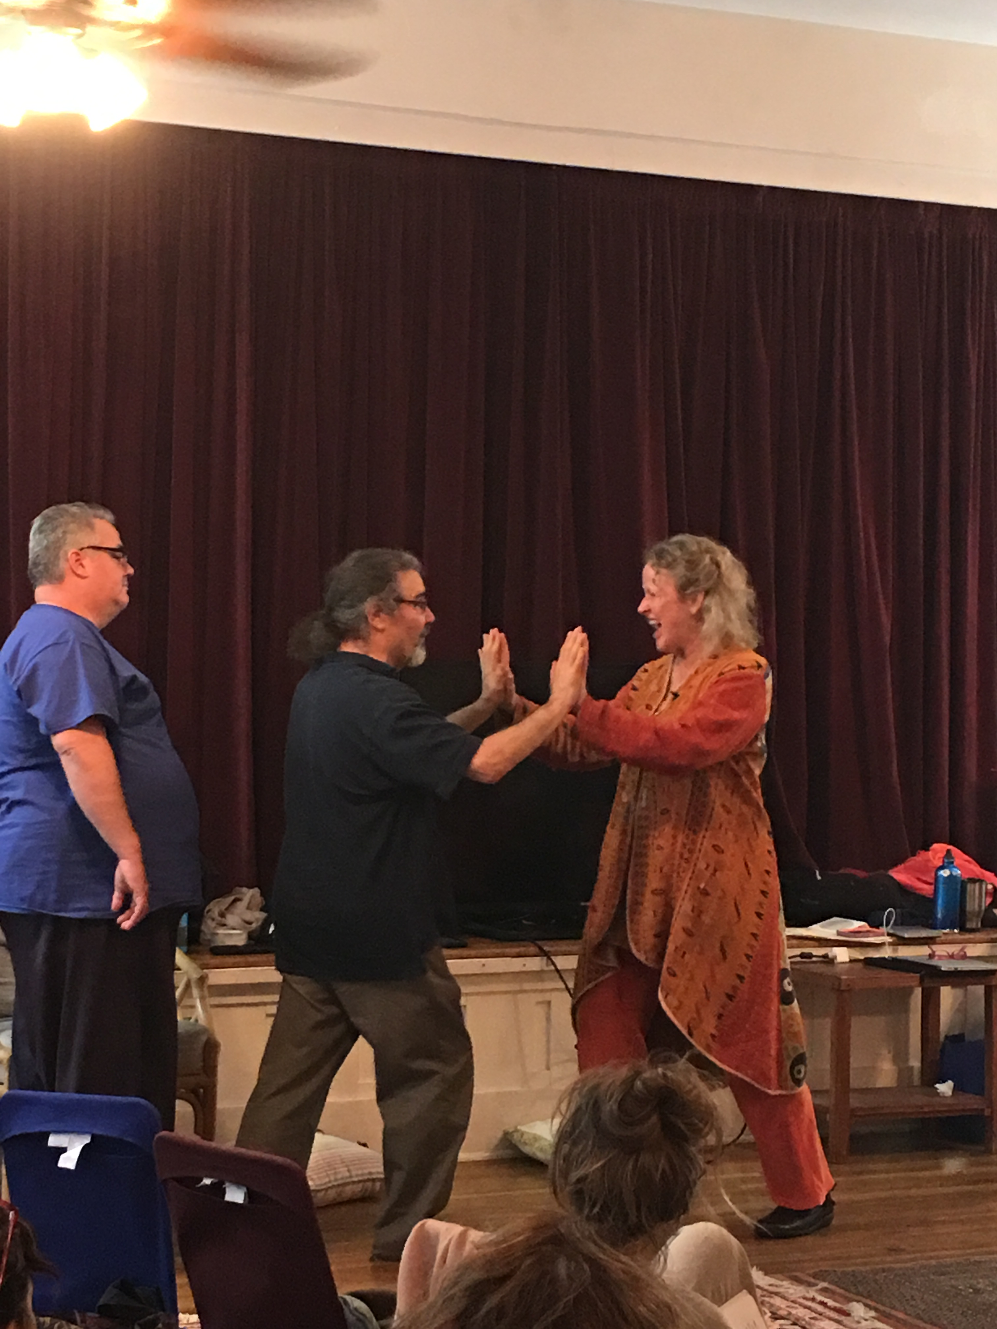 2**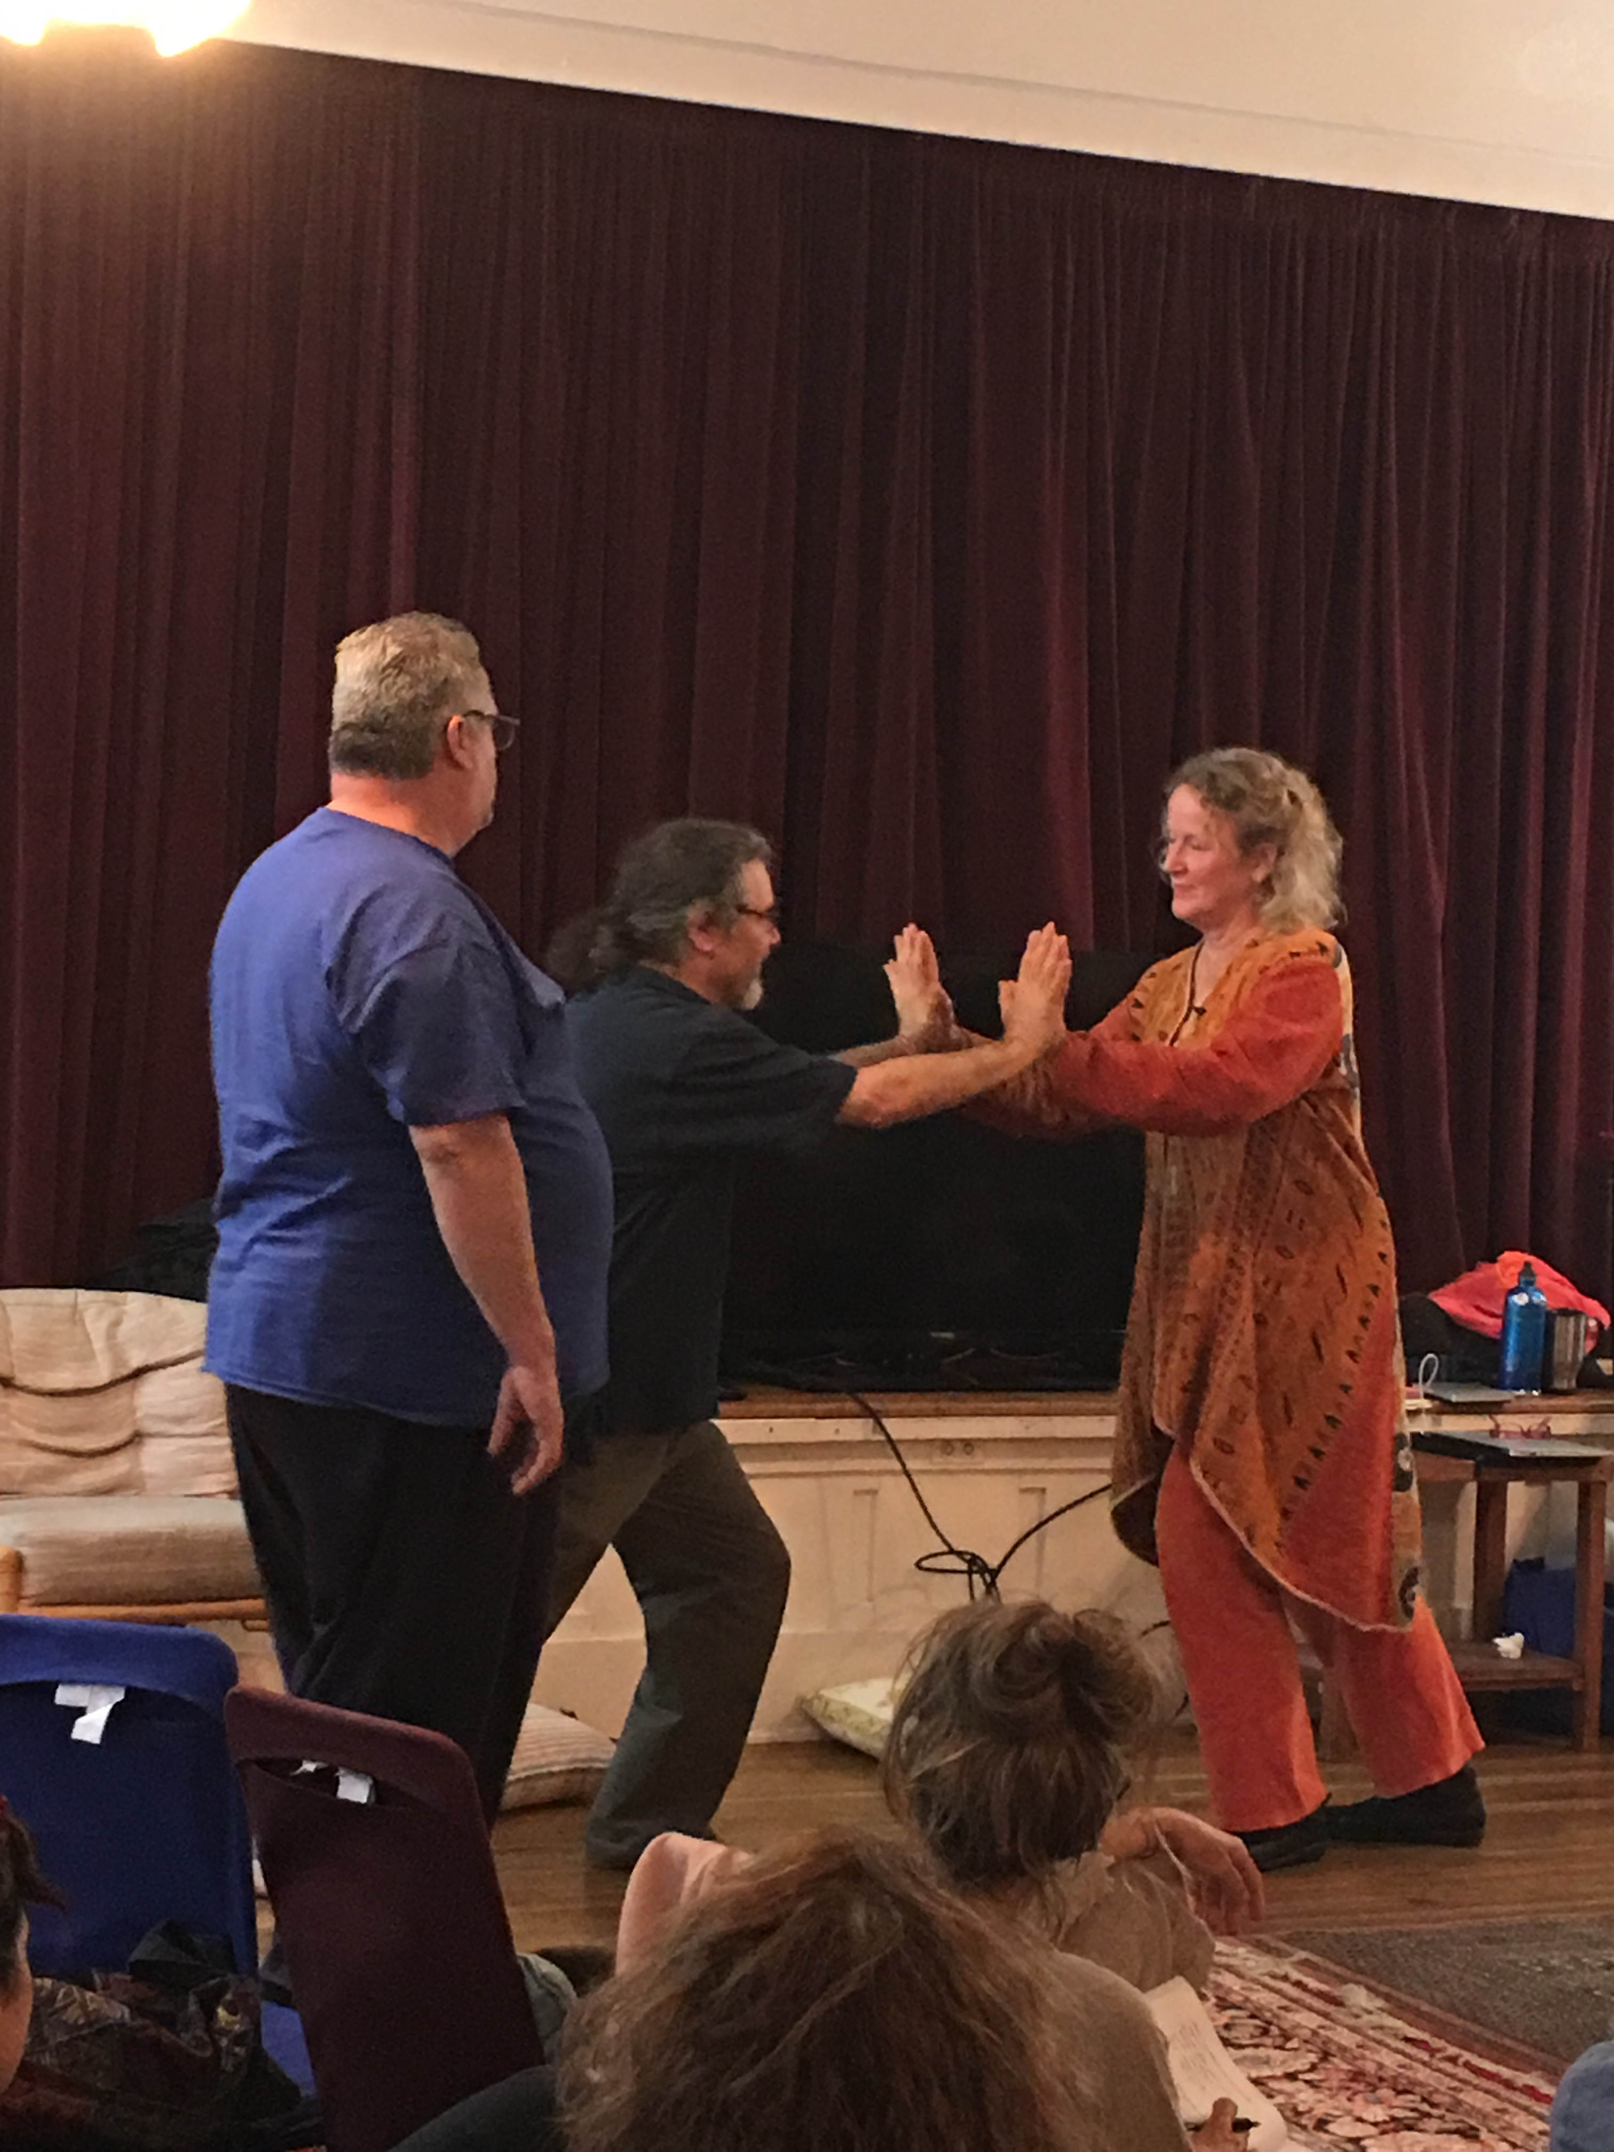

**3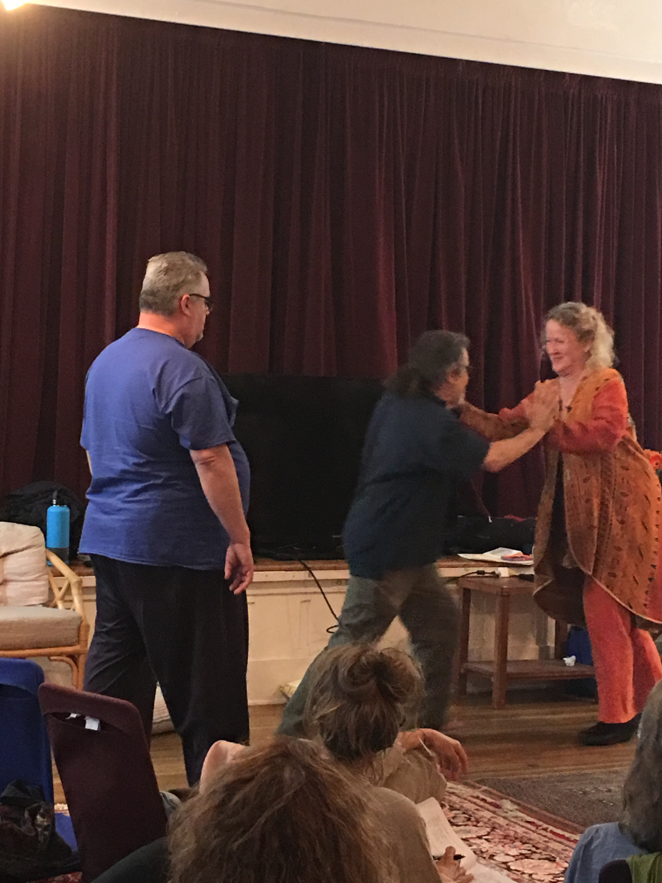 4**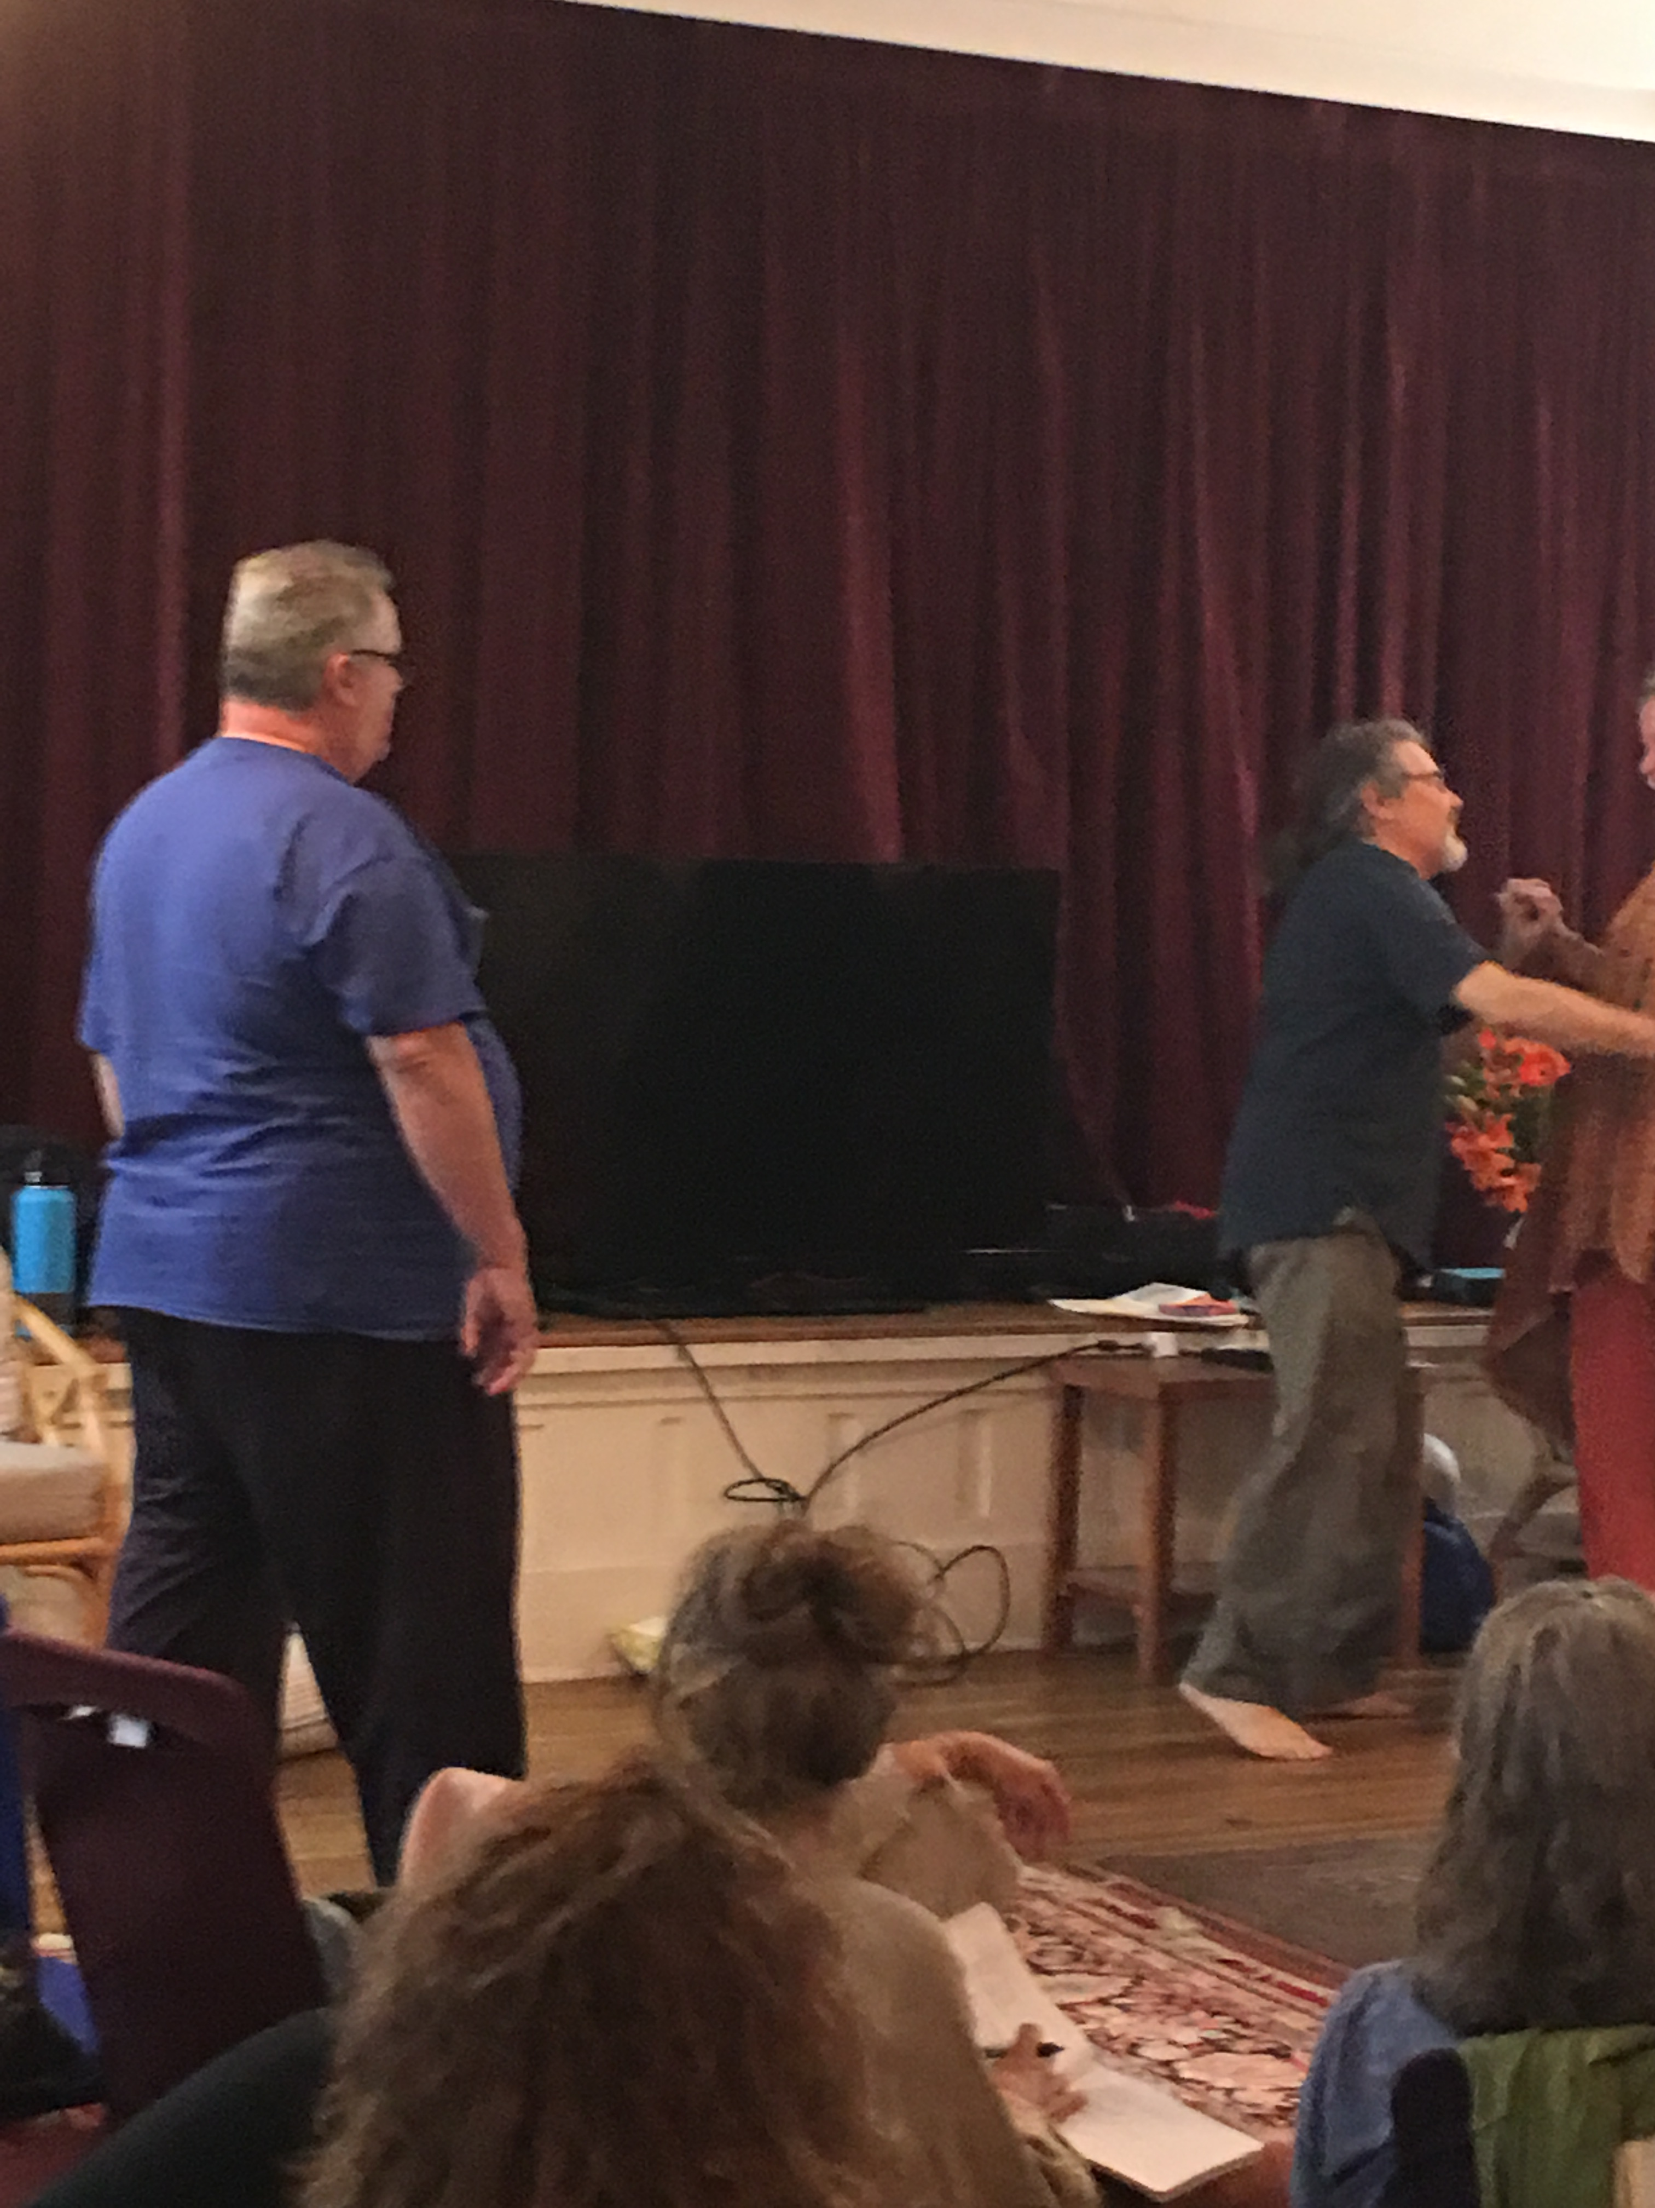

**If your history arises to remember ME FS, eye contact, move in it mutual support and cooperation, pause/stop and stay within the range of your capabilities.**

**Day 3, Wednesday, Nov 16, 2016**

9:00-9:30 AM Office hours

9:30 AM Orient to the day

Check in

Harvest creative opposition with attachment history

Homework Leading edge

12:30-2:30 Lunch

2:30-5:45 Afternoon session

First Touch

Noah Video

Yesterday we were out of sequence. So if you are disoriented its understandable.

During check ins notice when you feel yourself speeding up and slowing down.

25 minute each way. Get with one other person and check in.

Check in. The task was to pay attention to speeding up and slowing down. The task was for the listener to notice their own speeding up and slowing down.

Then you can observe how that affects the system. It relates to the window of presence. If we rev and name we are speeding up, we can start settling down and

You can name I am speeding up and then the person telling the story can have it reflected back not as a demand or request to slow down but to come into a mirroring and naming. Its really easy when we get very excited we can go out of the window there can be out of an expense to stay in harmonic resonance. Bringing into awareness the speeding up can be a gentle reminder to stay in resonance.

When you are sitting with a family you will see the family repeat play over and over again, and we notice it gets refined. All the experience in the room is very valuable. It’s not so much about the exercise as about sharing your experience.

One of the components of Bonding and Attachment is about fire. Umbilical affect is how the fire distributes thru the persons body. How that fire is organized thru us is how we approach life. You coalesce the gathering of the energy one will be at the will of their rage; it’s about passion and harnessing and allowing it to transform into something different.

Harvest DCO

Giving just the right amount of resistance, allows for relationship. Following the edge, enlivening, challenging, ebbs and flows, its mysterious. We are learning how to stay just at the leading edge, not too much or not too little resistance. When we support the birth story, we place our hands at the feet (hands can act as the fundus) we can also give resistance with our attention. Its tone! Bring tone to the situation.

I had no potency, and I felt no potency. Ray, There is potency in the frustration. I wanted to give up but then the potency gathered and by the time I felt the potency the other was no longer there and had abandoned me. Ray and M this is the sequence and events that tell the labor story. Mothers often want to give up just as the big push is about to happen. This is a story with lots of information.

If I feel pleasure something must be wrong. Having the just right resistance speaks to the functional range. The space between merging and resistance, a merged state does not give us the capability to know where I begin and you end. It can feel good but it does not allow us to move freely.

Homework check-in. Often the resistance is the leading edge. The more resistance we have to do whatever the more energy we have on it. The more energy is wasted on it. Find the why of the resistance and it will free up the energy.

We want to take a few minutes talking around the homework. You did almost an hour debrief. I want to know about leading edge and challenge. What is the difference between the two? Putting off homework. Would putting off be more imprint or blue print? If it were blueprint what would be the leading edge? If you have a dull knife you are likely to get injured.

Ray’s definition of confusion, “two or more things going on at the same time.”

In confusion there is a need for pendulation. One of the reasons we give you homework we need to practice giving language to preverbal experience

Leading edge, when working with kids, they come up to the edge and back away repeatedly. There is an edge where the system opens and there is curiosity to it. Some challenge and some curiosity, some enlivening and attracts more life. As in trauma you go to the edge of it and learn from it, and feel yourself grow.

Frankly Sills talks about perturbation, Peter Levine talks about warble, where you if keep going you can go over the edge or there is the possibility of finding challenge, and building potency just at the edge before the warble fully engages.

Short history of Bonding and Attachment

Key names and players of BA

Sir John Bowlby, Psychiatrist interested in kids who were institutionalized. He got an idea that the kids did not have attachment figures. He decided to study them. Out of Bowlby’s work, mom has to perceive in herself the baby and the baby has to perceive the mother in herself. Bowlby worked with babies post world war. He noticed that babies that were not held did not thrive.

Mary Ainsworth responded to his request for a research assistant. She created “strange situation” in 1969 to observe attachment relationships between caregiver and a child. They would bring the child (1-2 year old) to a strange room. The child was not previously traumatized. They wanted to see what would happen if the parent left room? They used observational methods for this study. Mary Ainsworth devised an assessment technique called the Strange Situation Classification (SSC) that puts child in some distress

The procedure, known as the Strange Situation, was conducted by observing the behavior of the infant in a series of eight episodes lasting approximately 3 minutes each:

(1) Mother, baby and experimenter (lasts less than one minute).

(2) Mother and baby alone.

(3) Stranger joins mother and infant.

(4) Mother leaves baby and stranger alone.

(5) Mother returns and stranger leaves.

(6) Mother leaves; infant left completely alone.

(7) Stranger returns.

(8) Mother returns and stranger leaves.

First time the child was left with a research assistant the second time left alone. When parent returned they got the most input. They saw different behaviors with different children. One child might get upset, even with a nice Stranger, the child remained upset. When mom came back the child settled. The second set of children, when mom left had a hard time. The third set of children the mom left and the child did not react as if they don’t notice. When mom came back they don’t react that is avoidant CHECK OUThttp://www.simplypsychology.org/mary-ainsworth.html

Mary Ainsworth had a clinic in Virginia and Mary Mains was her student who at UCLA they started the Adult Attachment Interview. They got 20 questions and interviewed people, and then transcribed the interviews. They had a way to look at the language to feel whether the energy felt open possibility they called it coherent, if there was constrictive in the language they call it cohesive. What they found that two people could have the same story, one would be cohesive or coherent. Coherent narrative example Ray. My dad was brilliant he was injured a lot. The level of wounding he had inside that he would hurt his son like he had been hurt. If you hear the story you will notice the open possibility. Second story, yeah my dad knocked me around, yeah when my kids mouth off I knock them around.

They Ainsworth and Mains did another study with 80,000 pregnant moms and then did stranger person exercise. They found out that when mom and dads had coherent narratives 85% of the children had secure attachment.

Winnicott talks about good enough mother 30% of the time.

*Dr. Ed Tronick notes that typically, a parent and their infant are in sync only around 20 to 30% of the time. This seems consistent with what Donald Winnicott coined “the good enough mother [parent]” many years ago, and speaks to the fact that parents can’t be expected to be perfect, and that good enough parenting can still lead to secure attachments.*

If the seven principles are on board with the family then children tend to be more securely attached. Parents who are intending to heal themselves, the kids will coherently become attached as well. You don’t have to be perfect. What’s important is that we repair the ruptures.

In our work we are looking for parents and kids to come together in coherent play.

Mother and baby coming into coherency, securely attached child was upset that she left but when the mother came back they connected and came into coherency again.

Connection, self esteem mutual support and cooperation. They tend to be the leaders when they grow up. Ambivalent tends to cling or hit mother. Does not know if mom going to be there or not show up. Avoidant children go away, and are afraid to approach. Disorganized is very unpredictable, might fall on the ground, back into the mother.

Coherence of the story of the children shows how much securely attached they are. Therefore if we tell our story, and find coherence in the story, we can become securely attached. When we experience the parent’s come into coherent narrative, we can see that cohesive narrative becomes coherent.

**First Touch Exercise #5**

First step find groups of three

Brief check-in and define roles

Mother, dad (partner, support person) and baby

Intention: Want to drop in to experience what it feels like to experience of first touch.

Sit and settle

20 minutes each round

Discover what it is gather potency and experience impulse to move.

How do you come into first touch?

Its important when you come out of it you say, shifting attention!

If it gets too intense ask for a pause, back up, start again.

You are not obligated to go into the material just because its there. You can back up into the coherent place and start from there.

Order of roles: baby goes to father or partner, father to mother, mother to baby

**Day** 4, Thursday, Nov 17, 2016

9:00-9:30 AM Office hours

9:30 AM Orient to the day

Check in

Harvest

Harvest First Touch exercise

Noah Video

12:30-2:30 Lunch

2:30-5:45 Continuing Noah Video

Afternoon session

Circle of Security

4:30-5:15 First Round of session

When we check in this morning as listener notice when your tempo speed up and slows down.

Harvest: look around, see who is in the room, and connect with your group. What was significant, what you got that was useful, leading edge. Name the role you were in and ask permission from the others.

Had an experience whether it was an imprint from my own birth or the birth of my children. As baby I had total clarity about I wanted. I wanted mom and dad to come together and lay with them. There was playfulness; I was able to relax into it even If it had not been a part of my actual family. (Mary) You tracked into the anxiety with your mom when you were young and then it was there with your own baby. (Ray) I ask was this there before me. The answer also is that was there before you were there and you are not responsible. “Yes I am not that and I did not cause that”! Realizing that it was there before us can be a reparative experience.

When I was the baby I wanted it to go really fast and be done with it. In my own birth story I was home birthed and it was fast. In the torus (Family) (up and out and sympathetic charge) I tend to go out very fast and out. I recalibrated to drop it down and my brain totally changed, the body slowed down. I repaired by staying with me and not leave to be in relationship with my family system. Ray was that there before you? Yes it was there and you are changing the generations.

As baby the family was over focused on me, I kept scanning to see if it was safe. I want contact but not that kind of contact. The work I did was to get parents to connect. I even felt my body turn away from parents because I did not want that over focused attention. I did not even want touch or contact from parents.

As role of baby I was separated at birth. When mom put her hand on my thigh I could feel the unwinding in my nervous system. I could feel the support of dad on mom. I didn’t realized how tight my nervous system was wound up. Today I feel also most empty, more space for me.

When I was baby I struggled to get the contact and attention that I needed. I realize that I go into anxiety at every turn that I want get the right kind of contact. I felt that parents were trying to get it right and I could not feel my own potency. I found myself giving instructions/feedback, felt like hard work. R. It can be a challenge for a kid to raise a parent. Being baby was hard; I found being dad was easy. Just now I’m shaking, and a little settled. I guess I did not get time to feel my family settle and or me settling. When parents are trying to figure it out. They can get anxious about trying to do it right. Baby can feel the anxiety of that figuring out. From dad there was no expectation just I’m here.

My experience was I was trying to burrow my way back in. Did not know whether I was in or out. Disorientation, there was a pushing but not sure whether it was to get in or out. Noticed there was no impulse to connect with mom or dad. I could not feel any ability for my parents for them to receive me. I wanted to crawl out of my mom’s womb to be safe in the world. The womb was not safe. When you sit with that just now how is it to share, it’s a downward flow, a torus. A settling with a truth, loss and sorrow around this. There is a holding around here (points to umbilicus) when baby is in c-section, doctors take you out really fast and cut the chord really fast. Baby knows that it want to be with the mother, it can have a big impact as whether someone feels safe or not. Also crawling out of the womb can be a desire to finish the natural process of vaginal birth.

I needed to pull my parents hands together and it was integrating for my left and right sides. “Get your shit together because I’m coming in!”

One of our jobs as kids is to integrate our left and right brains. If the parents are not integrated as a unit the children will have coordinative challenges.

Noah Video

Watch this from a point of view that these folks are your clients. You will notice that inherently there is the form. When you watch, watch from perspective of Practitioner. Watch for the rhythm, watch for the principles, pacing, and pause.

This family was in crisis and the intake was rushed. Partner was stay at home dad and mom was a horse trainer. It had been 5.5 months since the baby’s birth. They had been told that if baby did not nurse today they would have had to put baby on formula. Baby was loosing weight, pumping diminishing returns.

There were difficulties at birth. Compounded by mothers personal history.

In order to get baby to the breast “you have to make your breast available”. She had a midwife, ended up at the hospital with suction extraction. Mom had had Kidney stones during pregnancy. There is part of HX there was sexual abuse with a family member. After the birth mom hemorrhaged, passed out, dad and maybe baby both thought that she had died. Many interventions in this story. This video is about bonding and attachment, dad had become the primary care giver as mom was on the road for work.

Some notes from watching the video!

When babies are born with vacuum baby can’t find their suck and they can be lethargic. When there lots of intervention it can dampen the fire for motivation. It can dampen the ignition. Babies will tell their story and when baby starts moving they may start making noises that mom made during the birth. It’s (noise) in the same sequence of the story. If they show their story first they can sit down and eat.

You see the principle of pause and of choice. In the hospital there is a loss in the felt sense of protection. Her experience was that she felt protected. Their intention (want to nurse) is the strongest lever you have in working with your clients. Exercise of negotiating distance and contact. One of the things about nursing is that babies need skin-to-skin contact. Notice I’m bringing in a differentiation voice. Make a differentiation statement. Noah, You did not cause this. Notice you go deep then you spread. You can see the ANS speeding up and then settling. My interest is not to go into this a whole lot. It is one of the things that affect tempo and giving whole lots of space. You will need to have your breast available. I get curious as we get to the edge of the story. Make eye contact with me, they negotiate eye contact. Look with your 40 year old eyes and are you safe? It’s important to differentiate present day. What ever happened back there Noah already knows about it. Mom says, “I was molested by my father”.

Ray, you can see I’m staying at her edge, I’m staying with her and I’m not going away.

Thanks for looking at me, and for looking with your 40 year old eyes. In order to nurse you have to be in your present age. I will stand behind you with whatever judgment call. Mom names a breast infection. Antibiotics act as an astringent to production of milk. It will help with infection but not with milk production, it can shut down production. Ray moves to OA and forehead head support. We are making sure Noah does not have his own story. Why did you put the hand on forehead and then take it away quickly.

When you get towards 5 degrees forward you have to hold your own head. If they go too far forward they go into their own story. Stay within the 5% in the circle. Essential skill when client does not have tone in their neck. With babies its even smaller degree, as they do not have the ability to hold their head.

Bringing in your own story. It’s a felt sense of when you bring in your own story. Something in the shared empathy, helped open the field. In the WS we ask any one in the room have the same experience?

Notice the position of Noah’s head. The ‘his head is probably in the position that the head was for a long time in utero. Notice I first settled the mom and now I’m coming around to the dad and touching the baby. I’m seeing how deep in he is. Baby’s have the way of getting out of the way when parents need to do a piece of work. (Ray asks mom to place hand over son’s head, and Ray put his hand on her hand) “I’m going to do the same thing with him that I did with you”. In that way he is getting somatic permission from the parent to work with the son.

Question, what was the hardest part”? Noah’s breathing changes. Ray states “ I m not going to do anything that happened before”. When I ask that question the nervous system replays the memory. The hardest part was the vacuum on the head. It was supposed to be a very happy moment and something hard happened. You wanted something else to happen. You guys made it through that part and it was really hard. And it wasn’t your fault. Dad, he came thru it. Ray, this was the position from when he was born with head facing up. I’m discovering the level of resistance that is in the babies system. I’m feeling the expansion. Before you go there see you already made it thru. They (doctors) talked c-section, trial forceps and then suction.

Notice the tempo speeds up when you tell the story; in order for the baby to nurse you need to slow the story down. Noah’s mouth and tongue start moving. ”This is the same movement that needs to happen for baby to nurse. Baby fuses and baby is waking up in the story. Should I take him from dad? No he will move to you! Every baby has the instinct to nurse and latch on. Note when we went thru those places he woke up and started rooting. Mom states, “she has a headache.” So did you get an epidural? Yes. Go to the part of the story when you had an epidural. There were family and strangers coming in and out of the hospital room. My milk is coming in. The first thing is to get the felt sense of setting all the way thru your body. What we have been. So when they took you away from your mother, your mom did not want you to go. Mommy wanted to keep you right there beside her. So they connect with dad and miss connecting with mom. The hardest part for mom was they she was worried you were going to be OK. In order to eat its important you go to mom. Noah you know what to do. I’m putting my hand at your feet. Ray uses facilitated movement for the stuck shoulder. I’m not going to do it for him I’m facilitating the part he could not do for himself. The baby starts squawking, just sit there and the baby will do it. Noah that milk is coming down for you. Don’t help him he has to do his own work. See how strongly he is trying to latch. Baby latches. When he latches just support and you settle. Support your breast but don’t move him. Mom had been trying to get baby to remain on a latch. Mom says I felt like a child molester. Baby fully latches after this memory.

Headache comes back and new memory arises. Mom died at one point, passed out, and they thought she had died. See that mom survived and she is there right now. Where we are in the story is integrated. It’s the longest he has ever sucked, how is it for you. Mom, I’ve had to cram his head in order to get him to nurse. It’s beautiful to see you do what your bodies know to do. Baby went home and nursed for hours.

After the video

What we want to do with you is have a discussion around the Noah movie. Give homework for next module. Then we will prepare for two sessions tomorrow morning and a third after lunch. We will complete the day with harvest of the sessions.

How was that to receive that video? There was a journey where Noah crawled over to dad then to mom and I edited that out. In the hour of rich occitocyn after birth dad was with Noah. And dad stayed home and mom went out.

There is the instinct to scoop baby up and bring baby to breast. Or is it imprint?

Imprint might have speed and energy about it. Paying attention to what the emotions are that arise. Babies got 24 hours after birth to get to the breast. There is a compulsion to get baby to breast. But he actually has 24 hours to nurse. If they get to the breast sooner it’s easier to support. After 24 hours it’s harder to make the connection.

Baby needs to squawk in order to show story and get to the breast. The crying comes out of the limbic system less out of the brain stem. Ray asks what was the hardest part to the parents; this activates the limbic and brainstem and engages the fire and the muscles in the baby. Nursing doesn’t happen thru just the emotional system. We need to have just enough limbic system in order to engage the muscles. In this baby he had the strength but he needed to find it. The parents had to be in it with themselves and the story in it together. Something for Noah experiencing his parents feelings and then Noah could get to the breast. They had been trying to keep baby quiet. Sometime baby needs to touch feelings and story.

The big thing I got from watching the video was that you can help hold but don’t direct the baby.

That session took 2.5 hrs, which is the average length of the WS session.

Homework!

Disclaimer “Last time I verbally gave the assignment, some of you went and read what I wrote 40 years ago. If you go on the web site and see something different, I give you permission to be inspired and creative.

Assignment: How does imprints from sequencing affect your daily life. Discover some of your sequencing so you can differentiate yourself from the imprints.

Take three events (anything that has a clear beginning, middle and end) and note/track yourself. What was your process in the before, middle and as you head towards the end, and then take notes about what happens afterward.   
The reason you track three different events. Look for similarities that happened before, middle end and after.

Your assignment if you do it before the next module, it will greatly enhance your experience at the next module. Look at that data and draw conclusions and correlation. Write a page or two from your conclusions.

After the next module you will go from what you have gathered about your birth.

For the third module you will need a doll and pelvis that you need to contact Sandra about this.

Take the summary and send it to the reader

Get at least one other person in the training and when you are writing your summary check in with each other. Do that thru between now and the next module.

It starts the connection.

The form for a session

**THE FORM for this exercise.**

**Willingness**

**Willing to start a turn**

**Who is going to be TP?**

**Intention**

**Relevant history (not so much getting into movements but doing coherent hx about what has happened to you –quest-statement.**

**Recheck intention**

**Debrief**

**Form for debrief,**

**1. Restate intention in present time**

**2.What did they get out of it?**

**3. What part of the session they would like to focus on to support integration**

Before starting the session.

Name principles. Check in with each other. Roles decided first. So the first facilitator can start the session. Are you willing to start a turn? If someone is not ready to start a turn find out why. Tend to that. This can give you lots if information. Discover whose turn it is. State the roles, Name intention

Facilitator, support person turns person. Turn person goes to support person

1:15 per session. 15 minutes is a debrief

Once the Intention is stated, see if you can support their intention. Check with support person to see if you can support.

Relevant history. Turn person states part of their history. Choose a person to tell their story and then let the story come. There might be a body movement that you want to explore, or more conversation about their history.

What has happened to your to your question and intention.

Re check intention

Think about inquiries you have about your own bonding and Attachment

The intention shapes how the session goes. Keep relating back to the Blueprint.

Re state intention and support integration.

After the debrief, all three of you will talk about how it was for each person.

The focus is on practicing being the facilitator not having the perfect session.

You will notice there is a sequence to preparing for the session. It’s all information.

The middle starts after are you willing to start a session. Don’t skip this part.

In WS that is when the session starts. It’s when the camera gets turned on.

If you don’t have them this time bring a recorder next time.

For these sessions we ask that you stay in this room or the entry room.

**Day** 5, Friday, Nov 17, 2016

9:00-9:30 AM Office hours

9:30 AM Orient to the day

Check in your session group

10-11:15 -AM first session

11:30 -12:45-second session

12:45-2:45 Lunch

2:45-4:15 third session

4:15-4:30 Break

4:30 -5:45 Harvest

If we come to assist we will ask; what the roles are, who asked for support, what are the challenges, what is their intention, and what support do they need? If assistants join you, they may stay a bit longer but they are not taking over the session. When the need clears or shifts they may go to the next place.

Afternoon of Day 5

Harvest from three sessions.

What questions came up?

What did you learn?

As facilitator, finding balance, you know what her intention was. What was going on inside you? I have the same place inside, where no one knows what’s going on. You are looking for a way to make connection. Especially if its touching your own material. If you know what the intention is and what was going on inside yourself. I have that place inside myself of no one is going to know what is going on for yourself and for her. The key to the connection is what is going on in you, especially if it touches your own material.

Yesterday, Noah came alive when mom touched on her own material.

When I’m concerned for you, Part of the history was having an injury that had not been acknowledged. At the same time I was resting into the contact.

You can say “I want to really connect with you right now”. I know you are there baby and you are going thru something.

Mary I like to work touching the window of functioning. In my gut it feels like it’s been long enough, (trembling in my gut) I give them a cue to open their eyes, look around .I pendulant to resource. Ray Also they have an intention, you ask them to name their intention, and ask “how are you doing meeting your intention just now”?

Somatic stuff lets you know their brain stem is active; the emotional stuff lets you know the limbic brain is active. Restate their intention. That pulls more left-brain in and a little more frontal cortex because there is social nervous system is happening. It could be they are in the habit of having that pattern. Next module we will take it into movement. If you have too much limbic system you won’t be able to get the layer of the hindbrain dorsal vagal area if the movement is not going slow enough.

I felt surprise at how I followed the form, and let myself slowly improvise; it felt almost easy to be facilitator. There is intelligence in the system and not meddling too much.

The form is a map so you know where you are in the session. The PPN it can be easy to get lost. Most children lack consistency they don’t know what they can count on. The form allows the system to settle and know where it is.

As Practitioner I want to know how much to go into wound, or dampening down the life force. How important is it to go into the wound, the trauma vortex? Life force is in that.

(Mary) I find it necessary for person to touch into where the trauma place is. Then they experience just enough so they feel seen, heard and gotten, before you can go into B.P. Need to go to the seen heard part before going to the BP. (Ray) There is lots of life force in HX, that store of energy influences perception of experience. Perception governs experience.

Blue print is different than Archetypal energy. BP hooks you up all the way thru, center all the way thru, and its grounded. Center, feel the power coming thru into the creation.

If you go into an archetypical energy (go into a bubble) it often can have the affect to splitting and go off the top of the functional range. It can go off the top “I saw Jesus Christ”. The strategy, find the leading edge, awareness of BP and touch the edge of the trauma energy, You go up to it, stay on the edge, you back off, you go up to the edge you touch it, back off it and back off and wait.

This strategy, if you get the right amount connection to energy, you find a whole new potential to something that’s been locked. Shift, we shift the way we remember. Not thru implicit memory we learn how to remember more cognitively. “You are believed”, they pretended like it did not happen. And someone knows it now. Instead of going into implicit we get a cognition, we get implicit and explicit come together, left and right brain start firing. You are feeling this right now and you remember then. Present day eyes, looking around the room, it happened. You can have use of the energy that’s been locked up.

When in practitioner role you felt an energy come up and it feels personal especially if you have a personal history and the history comes up. Perception governs experience. It feels as if they would only act. If that is there for sure you are in an imprint that was there before you were born. Back off, get into present day eyes, and negotiate the edge of that. In the prenatal milieu the enmeshment and transference is huge is greater than in post verbal session.

Each session was so different. It was so impressive that the form could stabilize the roles in each session. Stating the principles and do the form. That feeling of not knowing whether you are getting it right its transference, its visceral sensation and feelings in the implicit world. If there is a new mom and dad they are going to have that feeling of not doing it right. It’s natural and right to have that feeling. Go back to intention go back to the form. Back off and gather potency. If the potency builds and something happens next. In order to do it you have acknowledge and get over the shame of it.

When I was the turn person, there was a place where the intention was too big. We discussed if the intention was too big. Suddenly within those few minutes we pulled the attention away from focusing on finishing.

We have had a week on bonding and attachment. We are talking about the process of how we do our work. How many have experienced a piece of reparative experience.

How are we doing our process?

As P I tried to do it right, the more I tried and kept thinking how I was not make it work or make it right. What I did not do was step back and take a pause.

Ray, “just the tenderness of that places’. I experienced going to that layer of shame, it leaves me feeling responsible, and I have to make it right. In naming the shame you will have a whole new array of ways of being with that feeling. I can feel myself wanting to do everything right. Who would have been the person back then that couldn’t get it right? They then can be responsible to put the experiences back together; you can honor them in their experience. …When there is a TA or Instructor that can turn up the volume.

Tomorrow ~ what we want to do tomorrow:

How to take home what you learned this week, and what you take into your personal practice. Where does this fit in my practice?

How do you practically take home what we learned this week? How you can get support to practically take what we did this week in taking it home to your work?

As a new facilitator I could maybe leave the turn person leaving like I feel. Maybe there is something that would make it just right. I’m feeling a little out of sorts and a little off. I want to know how to help someone who is in this position. I don’t want to do this to someone else.

(Ray) You got something about how that attachment process happened for you and your family. It did not feel just right then, you were left unsettled. This is after the session time. Sometimes at the end of the session you feel some unsettling. Naming it in here in the group helps with the debrief.

**Day 6, Saturday Nov 19th, 2016**

**9:00-9:30 Office Hours**

**9:30 Orient**

**Check-ins in 10 groups, what you need, and support**

**Summary**

**Homework**

**Integration professional Q and A**

**Closure**

**Fine 1 PM**

**Recap of what we did this week.**

**Blue Print/imprint**

**Bonding and Attachment**

**First day**

**Skills attention, moving attention**

**Gathering potency**

**Finding where that is**

**That exercise pre courser to DCO**

**Come into contact with attention gather potency, and DCO**

**Showed the video of Alwen and supportive attachment, Labor and delivery creative opposition**

**This module was around healthy birth and B/A**

**When we do that the imprints always show up.**

**Definition of B/A and attachment style.**

**Finding what was not there**

**First touch exercise**

**Noah video. What it takes to latch for the first time**

**What skills were present in the video?**

**We covered ANS cycling, activation and settling, and “window of presence”.**

**Speeding up and slowing down**

**Torus**

**Highly aware of your own sequence**

**Coherent Narrative, important for supportive attachment**

**Brief HX of attachment movement**

**Form, creating safe container**

**Roles and changing roles clarification of changing roles**

**Sessions**

**Appreciate the challenges it takes to do this!**

**Mary Jackson http://birthinconnection.com/services/**

**Student Q and A I have this family with a newborn, how can I do this? How do I start!**

**Has everyone in the room held a baby? Start there. If a friend asks to come over, go over as a friend. Go with the intention of finding your way. Follow your passion.**

**When playing with kids. Number one is safety. If you see someone going out of functional range stop the play. Ray talks about knock me over game. Gradually increase the, more space more intentional. If there is other kids there bring the whole group together. Safety and empowering and hold the authority.**

**Question is about intention setting. What is the family’s intention? I wonder about sequencing and intention. Intention setting is close to the beginning. People who have difficulty in setting intentions there is an imprint from their family history. Look how safe it was at the early place to have your intention. The family does not see that the baby has the capacity to have an intention. Possibly in that family there was no space openly show their intention without it being trampled on. I want to know that I’ve figured out babies have the ability to show intention. Setting intention is a grown up thing to do. Do it with present age and present eyes.**

**You are in more traditional setting. How to introduce touch, sometimes you can start across, hold the boundary with your hand extended. I’m aware of that boundary and we are doing it. My intention is to support boundaries. Some highly traumatized person needs to have age differentiation. Right now we are doing what did not happen then, and we are creating a new experience.**

**Working with C-section. Just be supportive of whatever sequence they are in. Slow it all down, and support them to get thru all the way thru. The more technology, the more difficulty they have with transitions.**

**Notes collated by Maria Seamster and Colette Venier**